

PROPOSAL DOCUMENT

Vulnerability Assessment &
Penetration Testing (VAPT) Report

Unity Health

25 April 2025
© Sautech (Pty) Ltd. http://www.sautech.net

TABLE OF CONTENTS

1 Executive summary 3
2 scope of testing 3
3 Methodologies used 3
3.1 Nmap / Zenmap 3
3.2 Nessus 3
3.3 Greenbone Enterprise 4
Stay One Step Ahead of Attackers 4
3.4 OWASP 5
3.5 BRUTE FORCE 5
4 Infrastucture 6
4.1 Production Server – 41.76.215.242 6
4.2 Test Server – 41.76.215.103 11
4.3 VP Server – 41.76.215.103 14
4.4 ODS Server – 41.76.213.162 16
5 Reporting Conclusion 19
6 Auditors 19

Executive summary
The objective of this assessment was to identify security vulnerabilities, business logic flaws, and missing best security practices. The tests were conducted from the perspective of an attacker or malicious user, without causing any disruption to the functionality or performance of the application or network. Additionally, a comprehensive scan of the infrastructure was performed to simulate a real-world attack scenario, such as an internal network breach or exposure on a shared public subnet.
The assessment, including scans and brute-force testing, was carried out over seven (7) business days to ensure a thorough and methodical audit. These scans also examined unidentified connectivity options, such as packet SYN requests.

scope of testing

Security assessments include testing for security loopholes in the scope defined below. Apart from the following, no other information was provided. Nothing was assumed at the start of the security assessment. The following scope of servers were covered under the security audit:

- Production Server - 41.76.215.242
- Test Server - 41.76.215.103
- VP Server - 41.76.215.27
- ODS Server - 41.76.213.162

Methodologies used

Sautech performed various audit techniques that includes the following:

Nmap / Zenmap

Nmap, short for Network Mapper, is a free and open source tool used for vulnerability checking, port scanning and, of course, network mapping. Despite being created back in 1997, Nmap remains the gold standard against which all other similar tools either commercial or open source, are judged.

To deploy Nmap, users originally had to have some advanced programming skills, with the introduction of the Zenmap tool for Nmap, which adds a graphical interface that makes launching the program and analysing the returned output it generates much more accessible.

Nessus

Nessus is a remote security scanning tool, which scans a computer and raises an alert if it discovers any vulnerabilities that malicious hackers could use to gain access to any computer you have connected to a network. It does this by running over 1200 checks on a given computer, testing to see if any of these attacks could be used to break into the computer or otherwise harm it.

Greenbone Enterprise
Greenbone is the world’s most widely used vulnerability management provider.

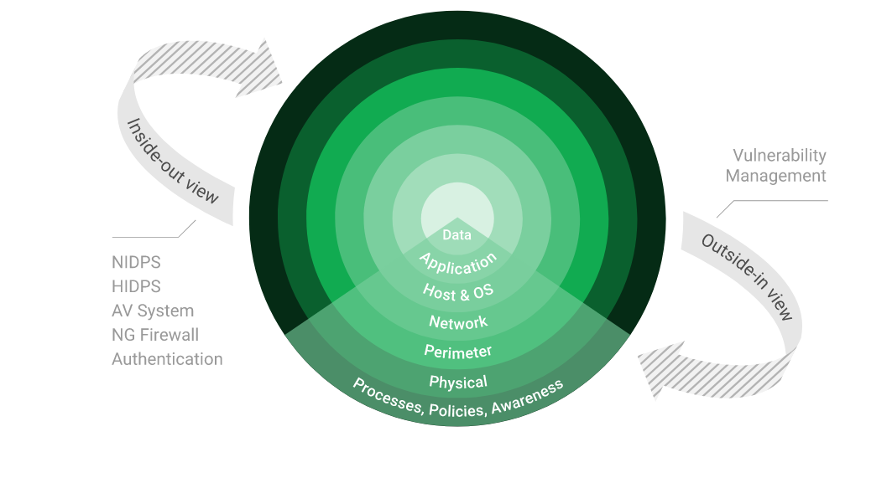

Stay One Step Ahead of Attackers
IT security is a process – Open Source vulnerability management provides the foundation. Once you know where the chinks are in your armor, you can do something about them.

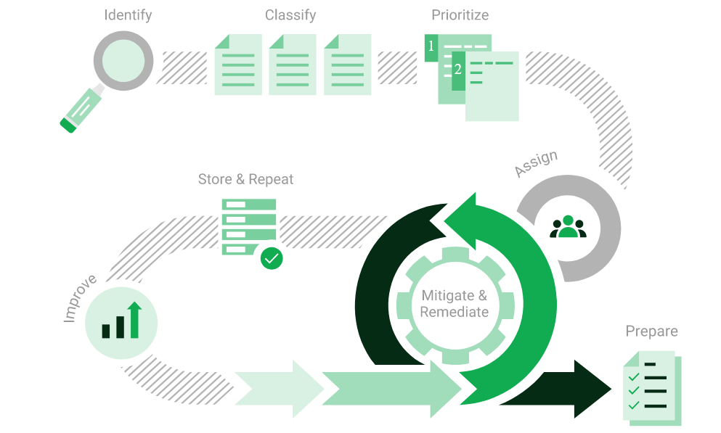

The process – from recognition to remedy and monitoring – represents a continuous cycle. You’ll always be one step ahead of attackers.

OWASP

The Open Web Application Security Project (OWASP) is an online community that produces freely-available articles, methodologies, documentation, tools, and technologies in the field of web application security. The Open Web Application Security Project (OWASP) provides free and open resources. It is led by a non-profit called The OWASP Foundation. The OWASP Top 10 - 2021 is the published result of recent research based on comprehensive data compiled from over 40 partner organizations.

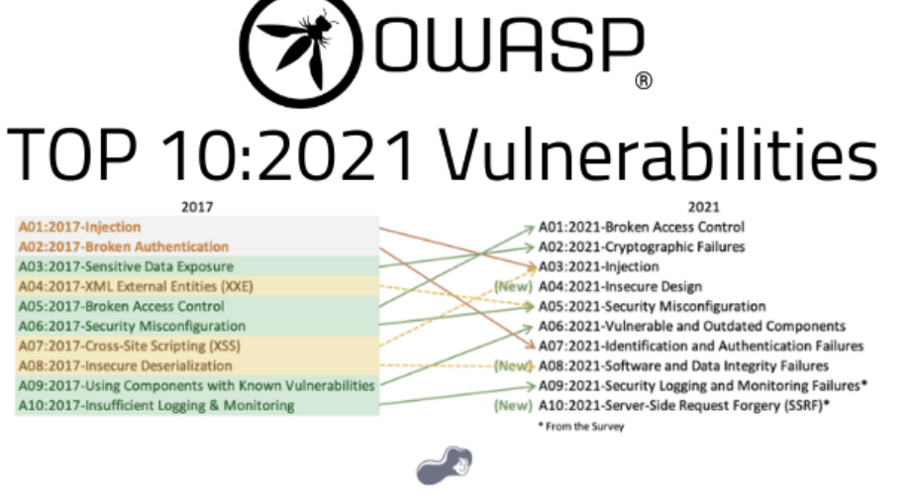

BRUTE FORCE

A brute force attack is a hacking method that uses trial and error to crack passwords, login credentials, and encryption keys. It is a simple yet reliable tactic for gaining unauthorized access to individual accounts and organizations’ systems and networks. The hacker tries multiple usernames and passwords, often using a computer to test a wide range of combinations, until they find the correct login information.

The name "brute force" comes from attackers using excessively forceful attempts to gain access to user

accounts.

Despite being an old cyberattack method, brute force attacks are tried and tested and remain a popular tactic

with hackers

Applications used in Brute Force Include:

Hydra is a parallelized network login cracker built in various operating systems like Kali Linux, Parrot and other major penetration testing environments. Hydra works by using different approaches to perform brute-force attacks in order to guess the right username and password combination. Hydra is commonly used by penetration testers together with a set of programmes like crunch,[2] cupp[3] etc, which are used to generate wordlists. Hydra is then used to test the attacks using the wordlists that these programmes created.

Over 2.5 Million + Username and password combos are used to Brute force application like RDP, SSH etc.

Infrastucture

Production Server – 41.76.215.242

We have performed two types of scans / attacks on the production server namely:

- Port Mapping (Open / Exposed Services) These were performed from unknown and known locations to test not just the security from the perimeter, but also include local network. Based on the port mapping open access to Public and Private, selected coordinated assessments were performed specific to the open connectivity received.
- Vulnerability Assessments.
- Brute Force.

Port Mapping - NMAP
Nmap can be used by hackers to gain access to uncontrolled ports on a system. All a hacker would need to do to successfully get into a targeted system would be to run Nmap on that system, look for vulnerabilities, and figure out how to exploit them.

The below screenshot demonstrates the open network port mapping:

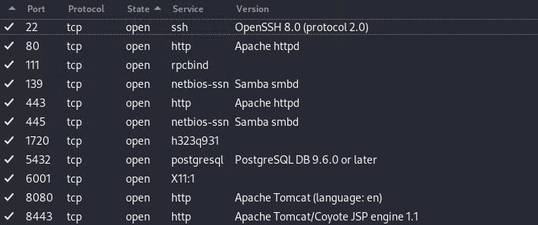

Remote Operating System Detection:

- Used Port: 22/tsp (open)
- Used Port: 80/tsp (open)
- Used Port: 111/tsp (open)
- Used Port: 139/tsp (open)
- Used Port: 443/tsp (open)
- Used Port: 445/tsp (open)
- Used Port: 1720/tsp (open)
- Used Port: 5432/tsp (open)
- Used Port: 6001/tsp (open)
- Used Port: 8080/tsp (open)
- Used Port: 8443/tsp (open)

Vulnerability Assessment - NESSUS
Multiple technologies were used to perform a vulnerability assessment, below is the summarised version of the relevant results:

We have attached the below “highlight” in a separate report so that you can click on the “Plugin” link to get the resolution.

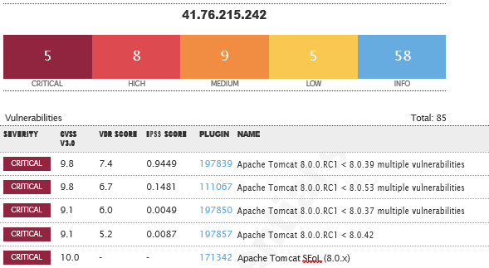
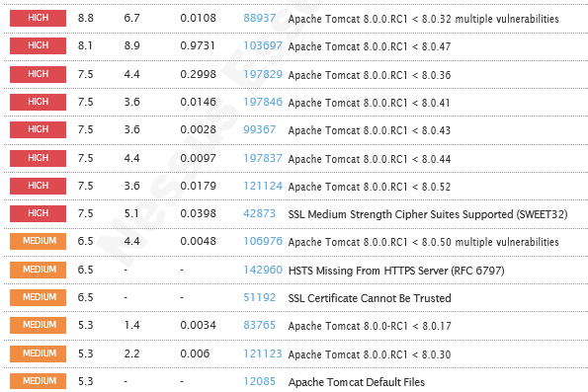
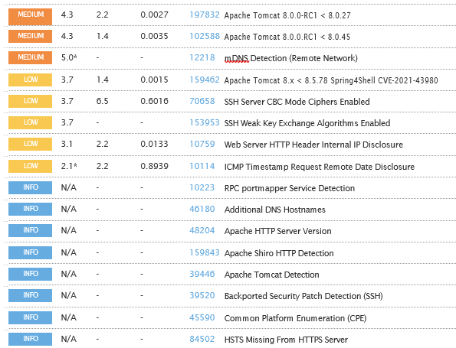
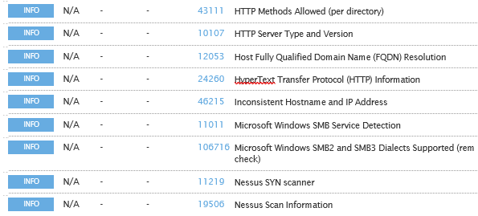
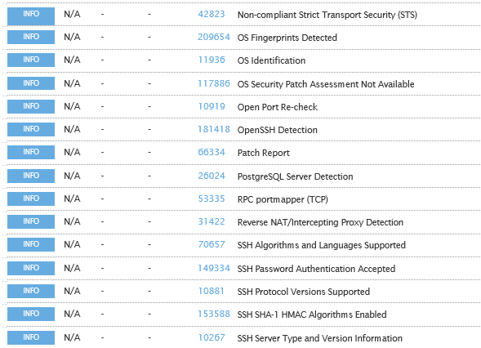
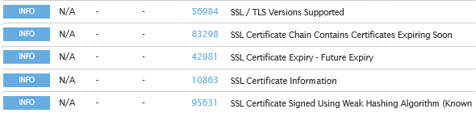

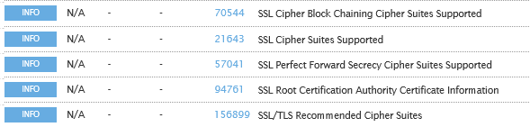
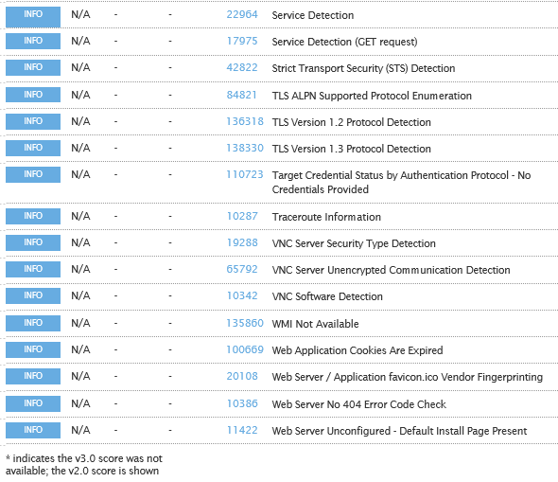

- Brute Force – HYDRA

Randomised usernames with a word list containing more than 1+ million words and common passwords were brute forced SSH’s onto the server using Hydra.

Hydra works by using different approaches to perform brute-force attacks in order to guess the right username and password combination. Hydra is commonly used by penetration testers together with a set of programmes like crunch, cupp etc, which are used to generate wordlists.

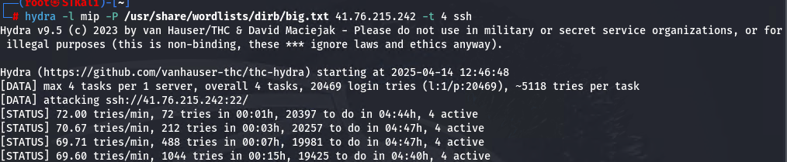

Test Server – 41.76.215.103

We have performed two types of scans/attacks on the production server namely:
- Port Mapping (Open / Exposed Services) These were performed from unknown and known locations to test not just the security from the perimeter but also include local network.
- Vulnerability assessments.

Port Mapping - NMAP
Nmap can be used by hackers to gain access to uncontrolled ports on a system. All a hacker would need to do to successfully get into a targeted system would be to run Nmap on that system, look for vulnerabilities, and figure out how to exploit them.

The below screenshot demonstrates the open network port mapping:

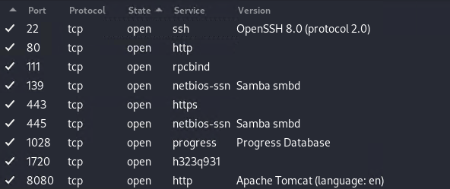

Remote Operating System Detection:

- Used Port: 22/tsp (open)
- Used Port: 80/tsp (open)
- Used Port: 111/tsp (open)
- Used Port: 139/tsp (open)
- Used Port: 443/tsp (open)
- Used Port: 445/tsp (open)
- Used Port: 1028/tsp (open)
- Used Port: 1720/tsp (open)
- Used Port: 8080/tsp (open)

Vulnerability Assessment - NESSUS

Multiple technologies were used to perform a vulnerability assessment, below is the summarised version of the relevant results:

We have attached the below “highlight” in a separate report so that you can click on the “Plugin” link to get the resolution.

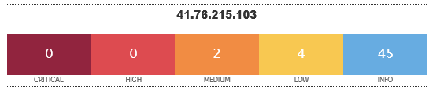

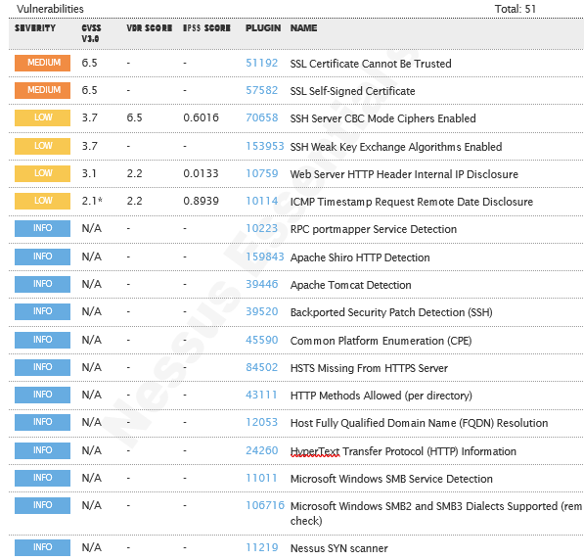

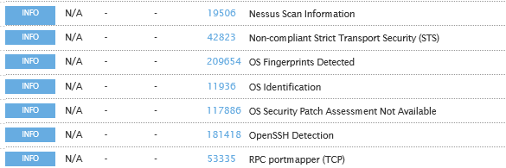
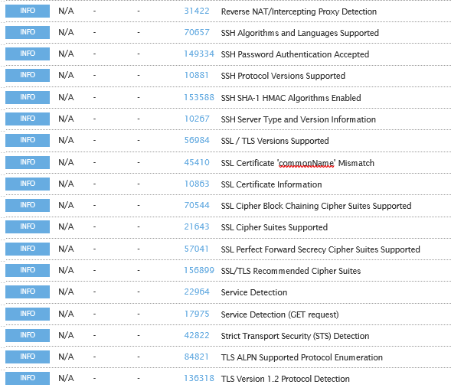

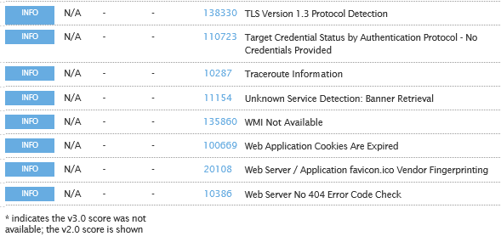

VP Server – 41.76.215.103

We have performed two types of scans / attacks on the production server namely:

- Port Mapping (Open / Exposed Services) These were performed from unknown and known locations to test not just the security from the perimeter, but also include local network. Based on the port mapping open access to Public and Private, selected coordinated assessments were performed specific to the open connectivity received.
- Vulnerability Assessments.

Port Mapping – NMAP

Nmap can be used by hackers to gain access to uncontrolled ports on a system. All a hacker would need to do to successfully get into a targeted system would be to run Nmap on that system, look for vulnerabilities, and figure out how to exploit them.

The below screenshot demonstrates the open network port mapping:

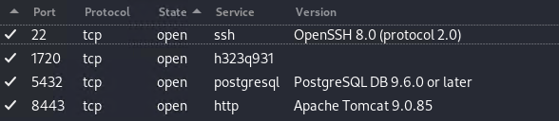

Remote Operating System Detection:

- Used Port: 22/tsp (open)
- Used Port: 1720/tsp (open)
- Used Port: 5432/tsp (open)
- Used Port: 8443/tsp (open)

Vulnerability Assessment - NESSUS
Multiple technologies were used to perform a vulnerability assessment, below is the summarised version of the relevant results:

We have attached the below “highlight” in a separate report so that you can click on the “Plugin” link to get the resolution.

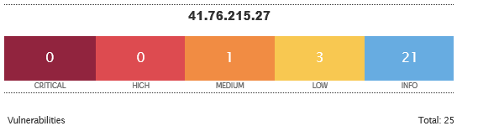

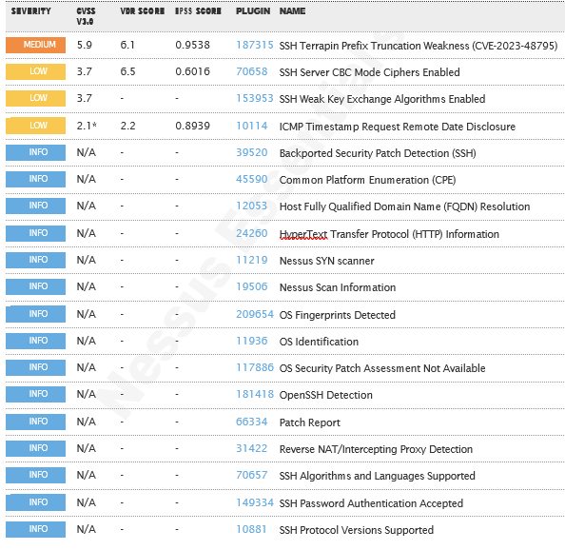
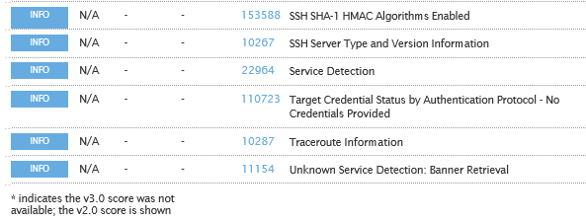

ODS Server – 41.76.213.162

We have performed two types of scans/attacks on the production server namely:
- Port Mapping (Open / Exposed Services) These were performed from unknown and known locations to test not just the security from the perimeter but also include local network.
- Vulnerability assessments.

Port Mapping - NMAP
Nmap can be used by hackers to gain access to uncontrolled ports on a system. All a hacker would need to do to successfully get into a targeted system would be to run Nmap on that system, look for vulnerabilities, and figure out how to exploit them.

The below screenshot demonstrates the open network port mapping:

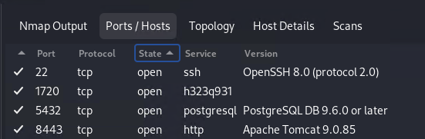

Remote Operating System Detection:

- Used Port: 22/tsp (open)
- Used Port: 1720/tsp (open)
- Used Port: 5432/tsp (open)
- Used Port: 8443/tsp (open)

Vulnerability Assessment - NESSUS
Multiple technologies were used to perform a vulnerability assessment, below is the summarised version of the relevant results:
We have attached the below “highlight” in a separate report so that you can click on the “Plugin” link to get the resolution.

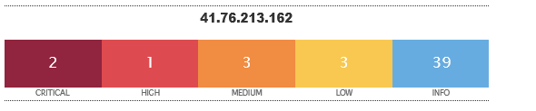
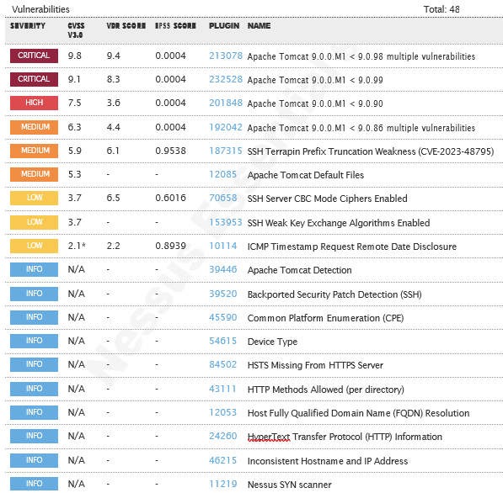
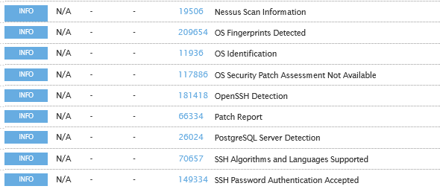
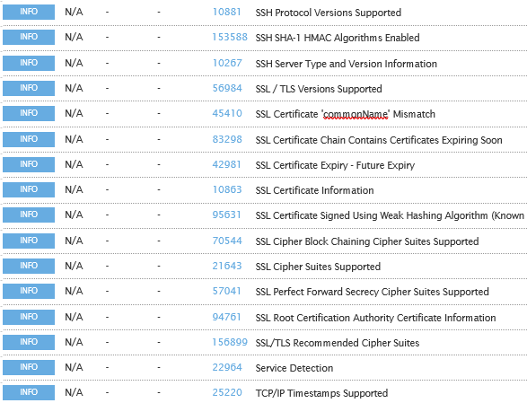
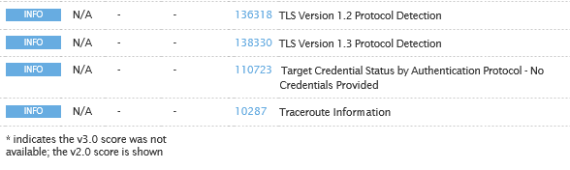

Reporting Conclusion

Based on the OWASP reports it is best to attach these separate to the reporting document. These reports can then be shared with the relevant contractors and/or support personnel to implement the changes and updates.

It is our view that from External Testing where the SSH port are not open to public, these vulnerabilities then become academic. However, we still recommend that the changes be implemented. Unity Health is behind the managed FortiGate firewall. Not even the public network can exploit the SSH vulnerabilities

The HTTPS updates as these are open to the public, low and medium risk, should be tested and implemented as soon as possible.

From a hosted infrastructure point of view, we are happy with the public external scan.

Eighteen (18) addendum reports are attached to this report and should be read as one document.
Two separate folders are included:
Folder 1: Public IP Scan – Main
Contains scan results performed directly from a public IP to target public IP addresses.
Folder 2: Internal IP Scan – Main
Contains scan results from allowed public IPs to internal production server IPs
With the following test performed:

- Network scanning
- IDS/IPS disabled
- Knows network attack (from Internet to the FW)
- External HTTP and Port exploits
- Vulnerability assessment on CVE
- Penetration testing on login ports i.e.: ssh open

Auditors

These audits were concluded over a period of seven (7) days.
We hereby confirm that the above information is true and correct:

25th April 2025 – Krugersdorp, South Africa

_________________________ _________________________
Riaan van Jaarsveld Lukas Janse van Rensburg
Security Expert – CCSA / Certified Pen Tester Security Engineer

